**Ali Emad Al-Deen** 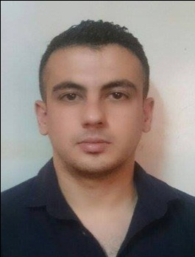

**Phone Number: 07714692793**

**Email:** [**ali1991emad@gmail.com**](mailto:ali1991emad@gmail.com)

**Address: Baghdad / Al-Yarmook**

|  |  |
| --- | --- |
| **SKILLS:** | |
| * **Proven ability to manage through others.** * **Strong decision making and problem solving skills.** * **Able to motivate and lead others in a team environment.** * **Able to priorities tasks and workloads in order of importance.** |

**EMPLOYMENT:**

**-Al-Salama Clinical Lab (Part time) (Location: Baghdad/ Beirut Square) From 2011 to 12/2016.**

**-Layaa S.B (Part time /Medical Representative)**

**- AGMEST Medical (Sales Engineer ) From 3/2016 to Present**

**EDUCATION:**

**B.sc In Chemical Engineering /University of Technology /Baghdad**

**Qualifications:**

**-** **Fluent in English language**

**-Excellent Computer skills**